**CSC 1100**

**Problem Solving and Programming**

**Fall Term 2015**

**Project 02**

**80 points**

**Due 12/08/2015 (12:00 P.M.)**

**The goal of this project is three-fold:**

1. Discover how to create and pass a one and two-dimensional array as a parameter to a function
2. Discover how to manipulate data in a one and two-dimensional array
3. Learn how to search a two-dimensional array
4. Learn how to search and sort a one-dimensional array
5. Learn how to generate random numbers
6. Being able to Analyze, Design, implement, and test a practical real-world application.

**Requirements:**

* Analyze the problem; outline the problem and its solution requirements.
* Design an algorithm to solve the problem.
* Implement the algorithm in C++, and verify that the algorithm works.

**Restrictions:**

You must work individually. Use only material from class or from the text book (chapters 1-8). All code must be the work of the individual. Do not share your code or copy from external resources.

**Grading:**

The grade of each program will be based on the creation of a program that works correctly, up to some details (30%), clear problem analysis and algorithm design (10%), the appropriate use of functions and arrays (30%), the production of clear output, with readable formatting and without unnecessary repetition (15%), composition of informative comments (10%), and testing the program with different inputs (05%). Programs must compile.

**Submission**

* Create the application program from scratch using visual studio C++ 2013.
* Type your analysis and algorithm for each problem in this file.
* Solve each problem and include the source file of each problem and this file in a folder. Name the folder (CSC1100_Project_02 Compressed the folder and upload it to the blackboard using the appropriate folder by the due date. No email or hard copy is accepted.

**Project Problem (80 points)**

Write a program that can be used to assign seats for a commercial airplane. The airplane has 13 rows, with six seats in each row. Rows 1 and 2 are first class, rows 3 through 7 are business class, and rows 8 through 13 are economy class. Your program must prompt the user to enter the following information:

a. Ticket type (first class, business class, or economy class)

b. Desired seat

Output the seating plan in the following form:

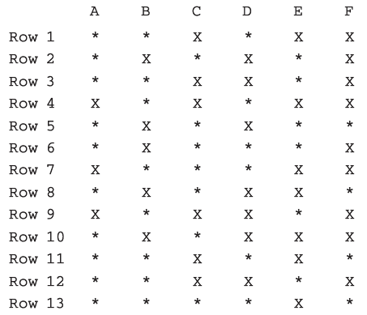

Here, * indicates that the seat is available; X indicates that the seat is occupied. Make this a menu-driven program; show the user’s choices and allow the user to make the appropriate choices.

**To design this I should start with making functions called menu, ticket, initialize, and grid. Menu would ask the user if they would like to reserve a seat, if yes is selected then initialize is called to initialize an entire array using for loops, from there grid will output the layout of the plane for taken and untaken seats. Ticket will then be called to be able to ask the user for certain seat types and their respective rows and seats, which the function will then go and set a value to the array other than 0 for that respective location on the grid, at which grid is then called again and prints the available seats with * and all taken ones with X.**

Sample Output

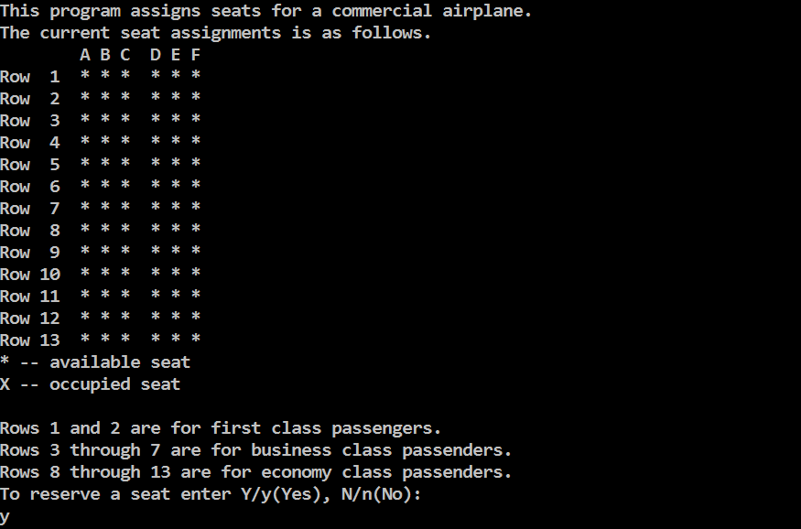

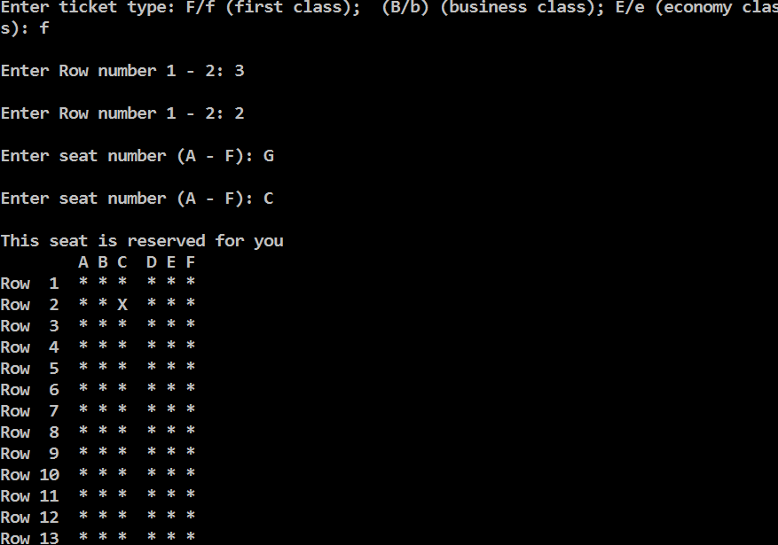

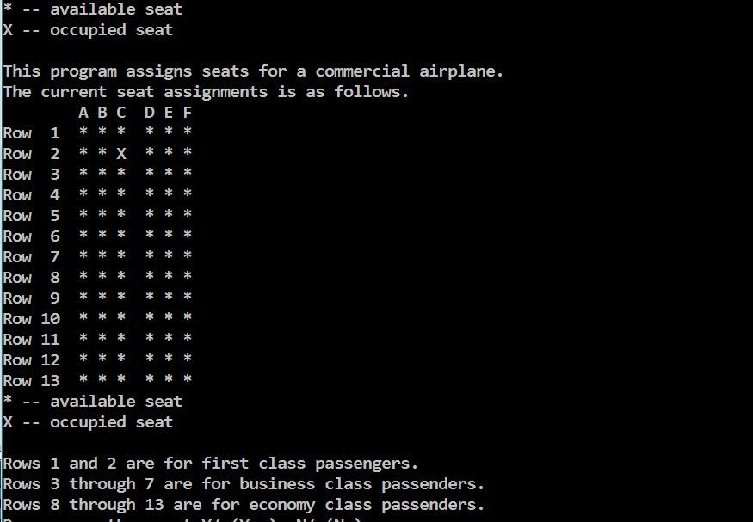

**Extra Credit (40 points)**

Your state is in a process of creating a weekly lottery. Once a week, five distinct random integers between 1 to 40 (inclusive) are drawn. If a player guesses all of the numbers correctly, the player wins a certain amount.

Write a program that does the following:

a. Generates five distinct random numbers between 1 and 40 (inclusive) and stores them in an array.

b. Sorts the array containing the lottery numbers.

c. Prompts the player to select five distinct integers between 1 and 40 (inclusive) and stores the numbers in an array. The player can select the numbers in any order, and the array containing the numbers need not be sorted.

d. Determines whether the player guessed the lottery numbers correctly. If the player guessed the lottery numbers correctly, it outputs the message “You win!” otherwise it outputs the message "You lose!" and outputs the lottery numbers.

Your program should allow a player to play the game as many times as the player wants to play. Before each play, generate a new set of lottery numbers.

**To make this program that would use the main function to ask if the user wants to play the lotto, if no then the program ends, if yes then function lotto is called where a for loop initializes an array uses numbers from rand() to randomize those numbers. Then the user will be asked for their input which will be saved in another array where every input is checked to see if that previous number had been chosen by comparing that value in the array with every other value in the same array using an if then statement. If any values are the same, the user is asked to choose a different number. Within the same for loop, if it checked if the number is between 1 and 40, if not then the user is asked to pick another number. An if statement then checks to see if the users answers are the same as the randomly generated numbers, if so then an output message of “You win!” is displayed then menu is called to ask the user if they would like to play again. If the answers are not the same then the display message of “You lose!” is outputted to the screen and the users answers and correct answers are outputted then menu is called to ask the user if they would like to play again.**

Sample Output

